BCOEL Steering Committee Minutes
June 12, 2019
Present: Brenda Smith, TRU (Chair); Darcye Lovsin, Douglas, Debra Flewelling, Douglas; Martin Warkentin, UFV; KarenMeijer-Kline; Ali de Haan, Acsenda School of Management; Lindsay Tripp, Langara; Lin Brander, BCIT (recorder)
Round Table
BCIT
- June Learning and Teaching Summit had an open education stream, Rajiv Jhangiani was the Summit keynote speaker; lots of workshops & events in the last months
- continuing with the open education grant program
- revision of open education guidelines underway
- the Open Education Working Group is now under the umbrella of Education Council
TRU
- open education WG established late Nov. https://oewg.trubox.ca/ (find Terms of Reference and other info here)
- working with registrar to denote zed cred courses (inventory done, low online form submissions so far) – see screen shot below
- strategic investment fund to provide open grants, funding for pilot project for grants now extended for 2 years; 25% release for a OER coordinator on campus – wanted instructional faculty
- open textbook sprint in May – History of BC, more sprints coming
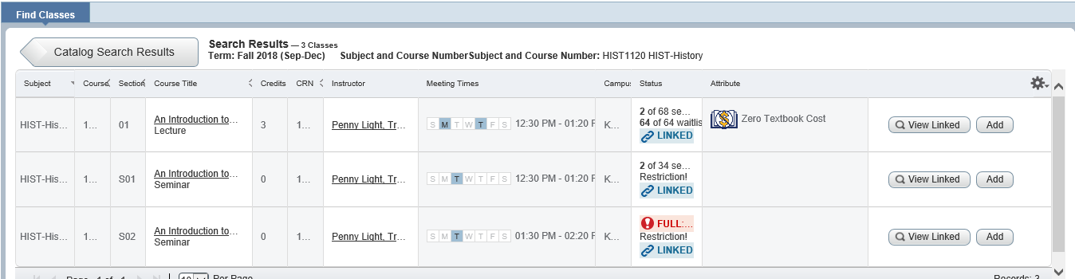
Douglas
- using a google spreadsheet to shares with BCcampus for updating open textbook use – goes through the bookstore list, follows up with faculty; will publish a list of open textbooks being used for summer semester on library blog; all Biology courses will use open textbook Anatomy and Physiology (1500 students per year);
- Zed cred going for Academic Transformations
- recommendation going forward to get release time for faculty to participate in open Douglas; incentive for faculty to add to PD funds $500 for adopting an open textbook
- Open Douglas planning for open access week – copyright, CC workshop plus wine and cheese event, H5P workshop
- Douglas Bookstore has announced that bookstore is not for profit.
KPU
- launching new Zero Textbook cost diploma of General Studies; name change from zed cred to zero textbook costs
- just hired library tech at Langley to support open projects – already have one in Richmond , not yet one in Surry
- looking at a departmental celebration package for repository submissions - contest
Langara
- working through the bookstore spreadsheet to gather open textbook use statistics - if there was a section using an open textbook, would verify and reach out to others teaching that section to see if they were also using an open textbook - OER clearly noted on bookstore list – 34 sections up from 4 - maybe better recording
- helped with kinesiology textbook,
- migrated to LibGuides – new open ed guide which includes open adoption stats and a VCC developed search tool for BCcampus open textbook collection (Lindsay will check to see if this search box can be shared) https://langara.libguides.com/open-education
- provided Lunch and Learn for curriculum review committee
- asked for a .5 OER coordinator, for now, library will fund a temporary position to do open project work,
- have 3K – trying to figure out how to use it - possible it will be used to fund a faculty member to attend Open Education Conference in Phoenix in Oct.
Brenda will share terms of reference
UFV –
- still having difficulty finding open ed champions at UFV, trying to identify people who are interested
- talked at teaching and learning community meeting
Acsenda School of Management
- basic math open textbook is being used – pulling numbers
- approval to set up a faculty learning community
Additional information: batch loading possible in Banner from a spreadsheet
Conferences
- Brenda will present at the Open Education Conference in Phoenix in October – ‘Not without my librarian: Developing OER advocacy and community’
- Karen will attend Milan Open Education Global conference in November – presentation on OPUS

Youtube channel content
- Should link it on website – consider subscribing to get numbers up, is some functionality to stream from it https://www.youtube.com/channel/UCYkjalQZNtja3MWuOnoMuNg
Working Groups
- Recruitment and External Engagement will change name to Engagement. This group will be responsible for maintaining and updating the BCOEL website, the Steering Committee blog, the listservs, and the institutional library contacts spreadsheet. Debra and Brenda will remain, Darcye and Karen will join. Karen will remain on Publishing and remove from PD. Ali will join Publishing
- Lindsay will contact people to start planning an joint institutional event for Open Access Week
- On Sept. agenda – do we want the BCOEL working groups to have leads? Someone who will shepherd the group work along?
- Reminder to remove content from Media Wiki by the end of June when it will shut down.
- Reminder that a decision was made in January that each institution will set up a place for presentation, workshop etc. materials that will be linked to from the BCOEL site.
- Suggestion that BCOEL might want to set up some workshops for more in-depth PressBooks training – LaTeX, HP5, accessibility etc.
Question was asked who is the BCOEL key contact at BCcampus – Amanda for now.
Lin is now Chair and Lindsay incoming Chair for BCOEL. Decision to have meetings Sept., Oct., Nov. on a regular day/time to see if that works for the group.

Website: https://bcoel.ca/
Steering Committee: https://bcoel.opened.ca/

