BCOEL Steering Committee

Meeting Minutes
Oct 20, 2025 – 13:00-14:00 / online via Teams
In attendance: Amanda Grey (chair), Alicia Arding, Ali de Haan, Brianna Henshaw, Hope Power, Ian Linkletter, Liz Johnston, Lindsay Tripp (minutes)

Agenda
- Welcome
  - Amanda called the meeting to order at 1:04pm
- Confirm Meeting Agenda
  - There were no additions to the agenda.
- Approval of Minutes from Sept 23, 2025
  - The minutes were approved as presented.
- Discussion Topics
  - Follow-up: BCcampus asked whether the MARC records they provide for works in the BC Open Collection are sufficient. During the last BCOEL steering committee meeting, it was noted that books are being labeled as a series when imported. However, it sounds like technical services teams at BC post-secondaries are addressing this internally. Amanda did not receive any additional notes from BCOEL steering committee members about further issues. She will follow-up with BC campus.
  - Open Education Week 2026
    - Amanda has updated the Events page on the BCOEL website with recordings from past events.
    - Amanda reshared the results from a 2023 Steering Committee poll to identify an OEWeek event theme:
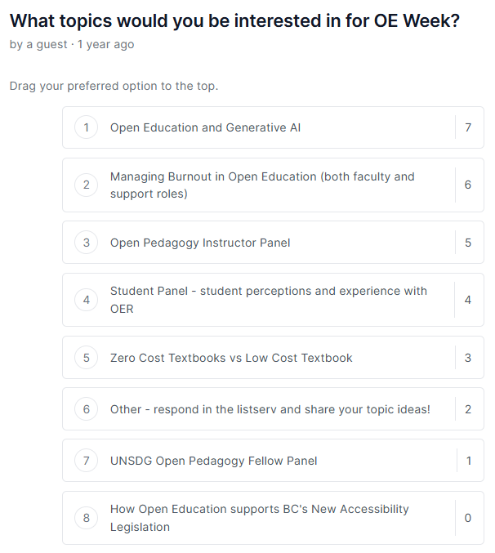
    - Ali, Ian, Liz, and Lindsay volunteered to organize an event for Open Education Week 2026. Amanda and Alicia also volunteered to support, as needed. The event must be held during Open Education Week proper (March 2-6, 2026) in order to: (1) advertise in the official OEWeek calendar, and (2) apply for BCcampus grant funding (if offered again this year).
      - SDG Month Canada is also held in March, so there could be cross-pollination between sustainability and open education. The planning team can keep this idea in its back pocket if funds are too thin for a keynote speaker.
      - GenAI continues to be a hot topic in open education circles. It might be interesting to look at this topic through a local (BC) lens.
- Roundtable
  - Amanda is attending the Open Education Conference (October 28-30, 2025) virtually and hosting watch parties to engage KPU faculty.
  - Douglas offered a community viewing session for Juan Pablo Alperin’s Open Access Week talk entitled “Who owns our knowledge? Rethinking publishing in a scholar-led world,” but no one attended. Instructors are busy and timing is tricky.
  - Liz is attending a talk by Sarah Lamdan (Deputy Director of ALA's Office for Intellectual Freedom) entitled “Data Cartels, the Companies That Control and Monopolize Our Information” this Friday (October 24) at 9am PST. UCW Library is contemplating putting workshops on hiatus, because of low attendance.
  - Brianna has been offering copyright mini sessions at JIBC. Some of the sessions intersect with open education. JIBC hosted an AI Week from October 6-10 that was fairly well attended.
  - Hope reported that a number of SFU campus partners (Public Knowledge Project, Library, Lifelong Learning) are collaborating on a new open publishing program. SFU is also conducting a student survey, which will include data from focus groups with students who are using OERs this term. The university plans to launch a new open education website in March during OEWeek 2025 and Hope is working with the SFU Bookstore to improve processes for instructors to report OER adoptions.
    - Tracking open textbook adoptions: Amanda previously pointed faculty to BCcampus’ open textbook adoption form in the hopes that it had more pull as a provincial initiative.
    - Douglas tracks ZTC courses and OER adoptions in collaboration with the campus bookstore. Alicia is working with the bookstore to revamp the form.
    - Note: BCOEL will be collecting OER adoption data for BC post-secondaries, now that BCcampus has shuttered this service. The data will be processed by KPU Library and published on an open dashboard. Karen shared a template spreadsheet for BC post-secondaries to use on the BCOEL steering committee listserv. KPU is looking for data from Spring and Summer 2025 to start with, but will also accept Fall 2025 data if it is available.

- Adjourn
  - The meeting adjourned at 1:33pm. The next meeting is November 17, 2025 at 1pm via Teams.

